GOTAhams Virtual Christmas party:

In keeping with what has become modern Christmas “get togethers” (really some form of Zoom parties)
This December we will attempt to create a fun interactive event with input from all our attendees. This time we will offer some questions that you will have plenty of time to consider answers to and link you to some on-line virtual tools to create virtual Christmas cards we’ll share with the group.
So, let’s get started!
Create a Christmas card to share with the group, for those attending by zoom save it to your computer to share it over Zoom. For those attending in person, bring a printed version to the restaurant. It can be as elaborate or simple as you prefer.
You can create the card by hand, and scan or photograph, create it digitally, you may even find one on-line that you would like to share. There are some free on-line tools you can use or whatever computer software that works for you.
Try these if you’d like, You will have to create a account to “Sign In” Canva – A tool that gives you heaps of templates, backgrounds, Christmas icons and Christmassy fonts to make a Christmas card within minutes.
PhotoScissors – A tool that helps you cut faces out of photos super easily and download them for use in Canva.
Next, during the meeting we would like to “show off” our ugliest Christmas sweater, for those attending at the restaurant of course “wear what you brung” we’ll have these folks do a runway type share walking in front of our camera. For our virtual attendees you have many options, just a sweater you have, a virtual background of something “ugly”, silly, ham related etc. or you can use a camera “virtualizer” like Snap Camera, cammask, youcam, splitcam, manycam, etc. if your computer has enough capability. This will allow you to virtually dress yourself for the occasion, even change during our time together!

Now let’s ask some questions that each person can answer during the meeting, We’ll keep them generic and try to avoid anything personal. These questions are offered ahead of the event to give some time for thought, allow you to consider which items you’d like to “pass” on etc. we don’t really want to put folks on the spot by surprising them with these. If you believe you’ve got a great question, please submit it in time to re-send the question pool ahead of our meeting.
- If cost were no object, what piece of radio gear would you gift yourself for Christmas?
- With a new year approaching, is there a radio related event you are looking forward to attending? Such as a HamFest, convention, monthly happening etc.
- In the new year are you considering trying something new in Ham Radio, like Satellite, HF ops, Digital either HF or DMR. NVIS? Or….
- Since the beginning of the Covid-19 pandemic have you attended any virtual hamfests, and/or become a regular ham related virtual content viewer?
- Have you found a Ham Radio related virtual content you have become a true fan of? If so which one is your favorite?
- Also, during the pandemic have you gotten comfortable enough with virtual attendance to continue attending events mostly virtually? Or do you prefer “in-person” events, maybe a mix of both?
- I know this may be more personal but for those willing to share, What are your Christmas plans or even New Year’s eve plans?
- A little humor: tell your favorite funny, bad, silly or? Christmas joke (or whatever joke you feel like telling)
During closing we would like to ask each attendee to address the group offering your Christmas greeting? Or simply say hello/goodbye…
PhotoScissors – A tool that helps you cut faces out of photos super easily and download them for use in Canva.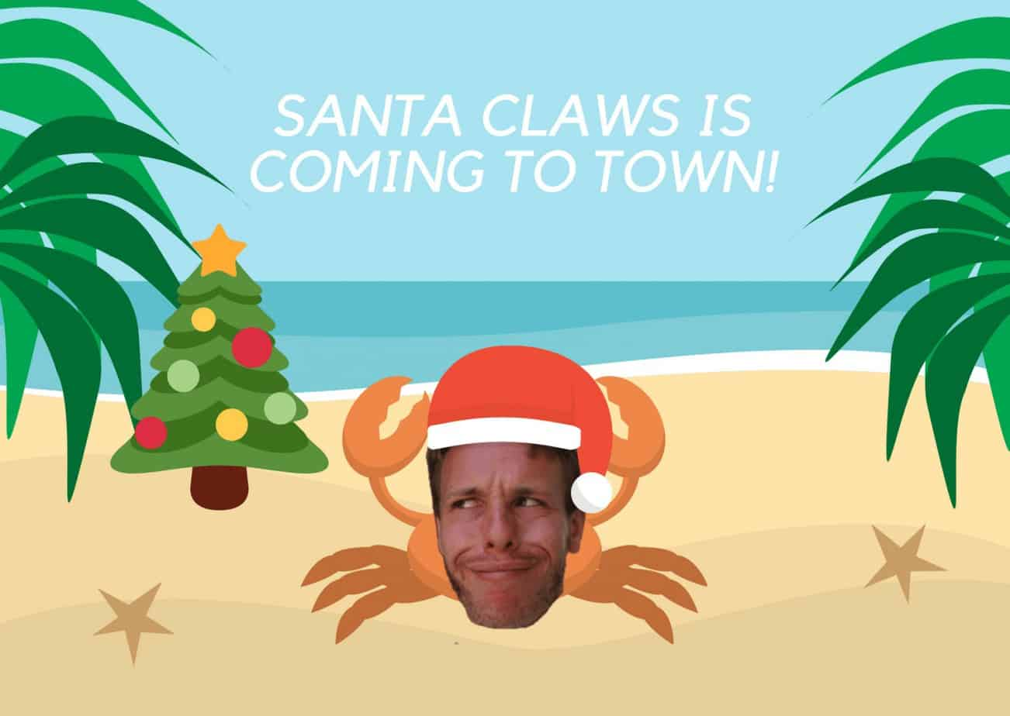

As you can maybe tell, we made the above image in about 3 minutes using both tools. We’re sure that you and your party guests can do a better job in just as quick an amount of time!

Get your guests to present their crafted creations during your virtual Christmas party. If you want to turn up the heat, you can promise prizes for the top-voted answers.

