GOAT NOTES
January 2022
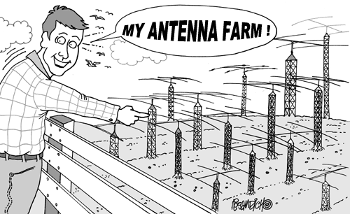

Step aside 2021 because 2022 is here!

We would like to welcome all our new members to the GOAT family. We gained a lot of traction in 2021 and in 2022 we are hitting the road full speed. So, with that said here is a warm welcome to all the new members.

Contacting the International Space Station by Dave, W6OOD
Gotaham Dave Wood, W6OOD contacted the International Space Station and downloaded images which were transmitted He writes:
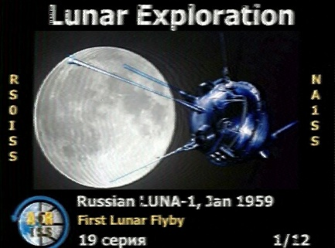
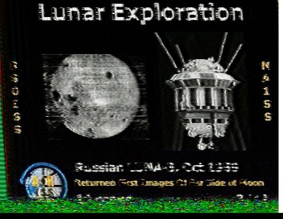

I had heard about the week of the International Space Station sending SSTV images constantly on 145.800mHz and prepared myself for catching it.
I never have had luck getting QSOs via satellite, but this sounded fun.
This morning I checked the ISS pass-over schedule and realized that one was passing in 8 minutes. I scrambled to put my equipment together and to record the data.
I followed the ISS with squelch open for about a minute and a half until I heard an obvious and very strong SSTV signal.
When I replayed the recording into my iPhone's Black Cat SSTV app this is the image that it showed. The ISS is sending a sequence of images all week giving us more opportunities to get more pics from space.
I am excited about my first SSTV and frankly, my first space ham radio success ever.
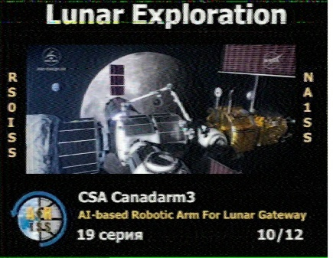
Attached are the recording and the image. This was all done with acoustic coupling, my receiver and recorder in the same pocket and then the recorder next to my iPhone with the app running on automatic mode. Dave, W6OOD downloaded additional photos.
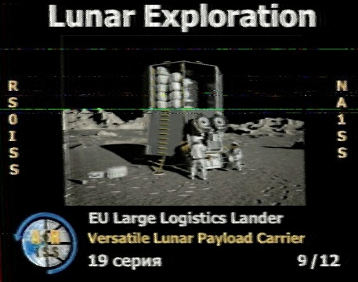
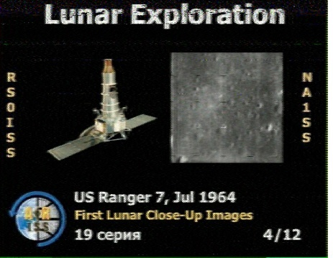
Well, I guess I am that strange neighbor that can be seen to be out in his front yard in the middle of the rainy night in his pajamas pointing a strange antenna at the “aliens” in the sky. But the payoff are these pictures I managed to receive this week.
I had heard about the week of the International Space Station sending SSTV images constantly on 145.800mHz and prepared myself for catching it.
I never have had luck getting QSOs via satellite, but this sounded fun. This morning I checked the ISS pass-over schedule and realized that one was passing in 8 minutes. I scrambled to put my equipment together and to record the data. I followed the ISS with squelch open for about a minute and a half until I heard an obvious and very strong SSTV signal. When I replayed the recording into my iPhone's Black Cat SSTV app this is the image that it showed.
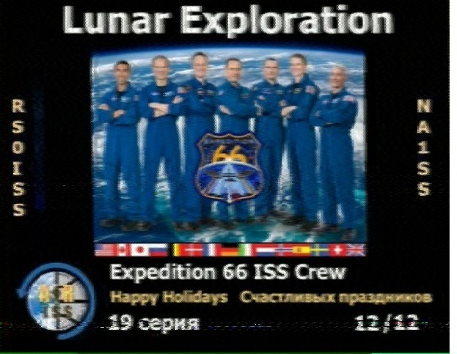
The ISS is sending a sequence of images all week giving us more opportunities to get more pics from space.
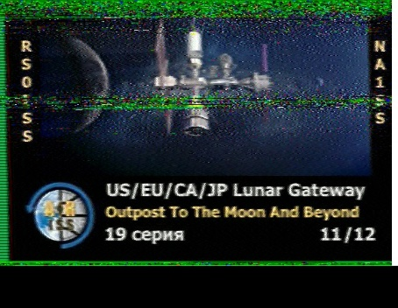
I am excited about my first SSTV and frankly, my first space ham radio success ever. Here are the images. Thank you,
David Wood
W6OOD
Jokes, Jokes, Jokes
Yes, the GOTA HAMS have a nightly net. Just so happens Tuesday nights are Joke Night with Jack KM6UNQ.
Grace wanted to share this long one with the group. It’s a bit long for a net. So, we are adding it to the newsletter. ;)
Parks on the Air (POTA) Facebook posting
12/16/2021
by Jim Fielder
I'm posting this with a heavy heart.
As much as I love the ham radio hobby, POTA, (Parks On The Air) collecting gear, trying new modes, and everything else that comes with it ...it is just taking up too much of my time.
I am struggling to keep up with the everyday basics of cleaning and maintaining my home, so something has to give.
I have decided to get rid of my gear.
Below is a list of what's available.
Serious inquiries only and
please don't insult me with low offers:
1. Vacuum cleaner
2. Dustpan and brush
3. Mop and bucket
4. Lawn Mower
5. Leaf blower
6. Laundry detergent
7. Iron
8. Broom
FYI the goats updated the Q codes for 2022. Here is a summary of them.
QLD: I AM IN LOCK DOWN
QUA: I AM QUARANTINED
QPD: I AM IN THE MIDDLE OF PANDEMIC
QTP: I HAVE TOILET PAPER
QHG: I NEED A HUG
QSH: I AM SHELTERING AT HOME
QHS: I HAVE HAND SANITIZER
QSD: I AM SOCIAL DISTANCING
QCV! I HAVE COVID
QWH: I HACVE WASHED MY HANDS
QWH? HAVE YOU WASHED YOUR HANDS
QSS: STAY SAFE
Monthly Simplex Net: 1/26/2022

We will be practicing a Simplex net on VHF 146.580 Wednesday night 1/26/22 at 7:00pm. All licensed hams are welcome to join in on the fun. This is a fun exercise and gives us the ability to see who we can contact directly with during a time of need for simplex operation. We just need to setup a cross band repeat for grace as she is the lone wolf who I can’t seem to hear.
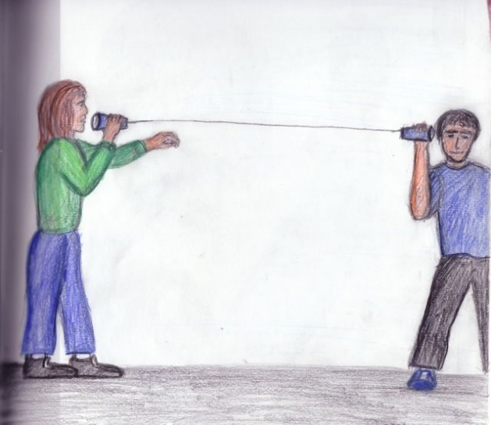

Gotahams website update:
As a friendly reminder the Gotahams have a store front on the website that can be at the following link. https://gotahams.com/shop/.
There’s lot of cool new Gotahams swag that you can purchase.
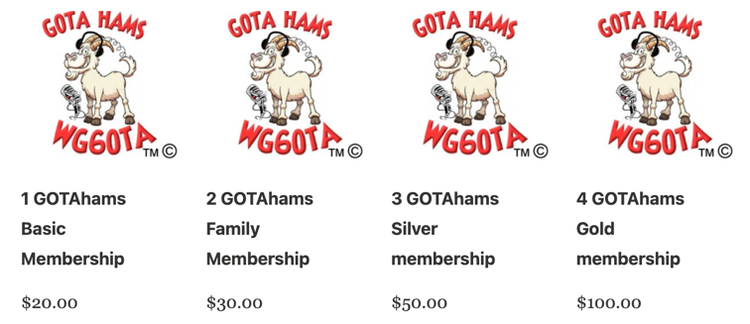
Oh, and you can now pay your membership fees there as well.
Which reminds me I need pay mine. So, if you are an existing member or a new member take a moment to visit the site. Remember membership is not mandatory to participate with the Goats!

Bragging rights:
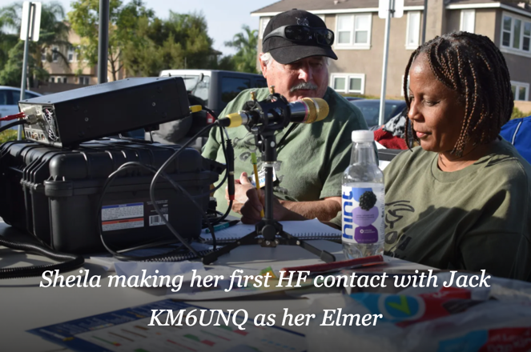
New GOTAham Sheila L Eure KM6KNO has successfully upgraded to Amateur Radio Extra class!
Sheila attended an In-person VE session with Tri City ACS and actually got a 100% score! The session was co-officiated by two VE GOTAhams, Craig KM6EIC & Kathi KD6CAF. And yes, her first HF contact was made on the FT991A ;) well that’s what is in the photo.

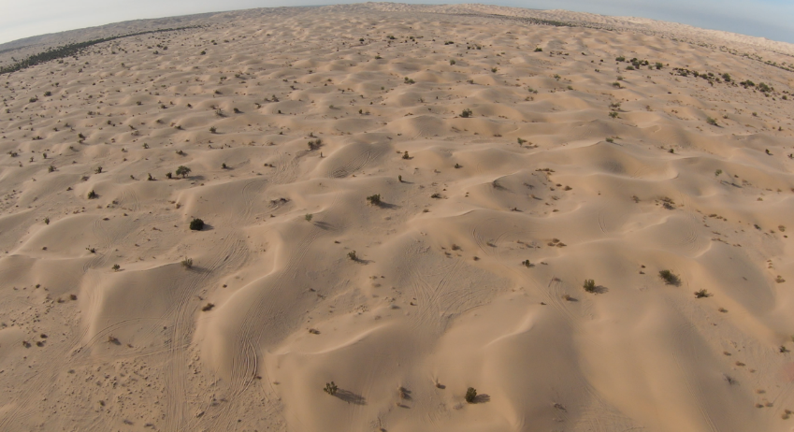
Glamis sand dunes last weekend from January 6th – 9th.
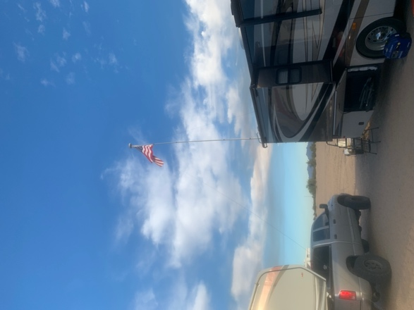
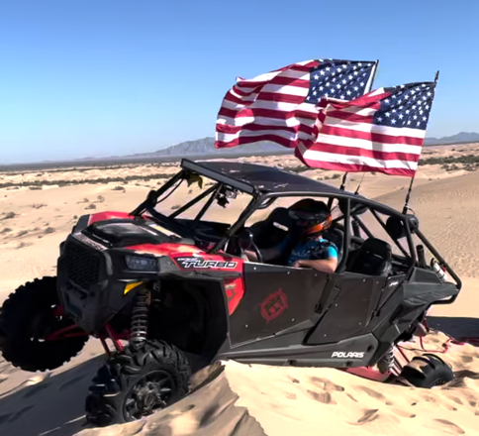
I decided to bring some HF equipment with me. The photo does not serve much justice, but I tried setting up my wire antenna as an inverted V. Just to see if I could reach Shaun on any of the bands. I was not successful at all. We could both hear parties talking on the bands but no luck reaching each other. I should spend some more time learning about antennas and using the buddy pole antenna I have. One day just not today! So that will be my 2022 resolution. It’s hard to see in the photo, but I have my wire in ran from the top of the flagpole on that RV. The second photo of the UTV is ham related because I have a VHF antenna between those beautiful US flags! And yes, I got stuck. LOL

Radio in the Park
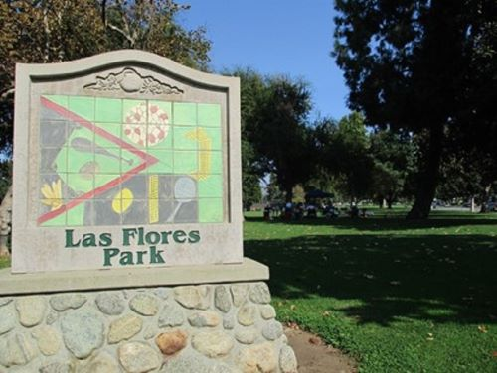
Gotahams get together at Las Flores Park in La Verne, CA for Radio in the Park December 18, 2021
Gotaham Sheila, KM6KNO attended the Radio in the Park, she enjoyed meeting new people.
She writes: Gotahams were back outdoors at Las Flores Park. The green open space with the antennas up was a welcoming sight for people excited about making contacts.
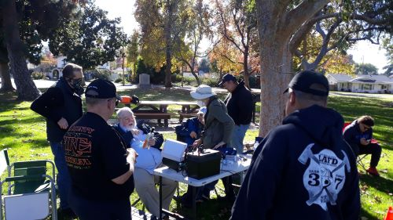
Dave, K6EV made 8 contacts reaching as far as Russia. Mark, KM6AHY and Edward, W6ABW borrowed a microphone from Dave to help with contacting other hams.
Sheila writes she had the joy of meeting, Grace, K6FS, another female ham in person, and helped roll-up wires of the antennas. It was a beautiful low-key day with plenty of time to socialize.
Dave, K6EV explains the antenna analyzer. Pictured is Grace K6FS & Mike, KN6HHW & Bruce V, KM6WBI with other radio operators for a day in the park.

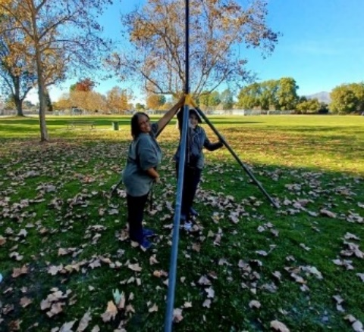
Sheila KM6KNO and Grace K6FS erect the antenna and get ready to play radio

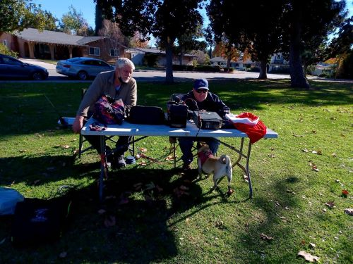

Edward, W6ABW and Gotahams President Mark, KM6AHY with Olive, OL6VE tune the radio to listen for traffic.

More Radio in the Park – Practicing for Field Day -January 15, 2022
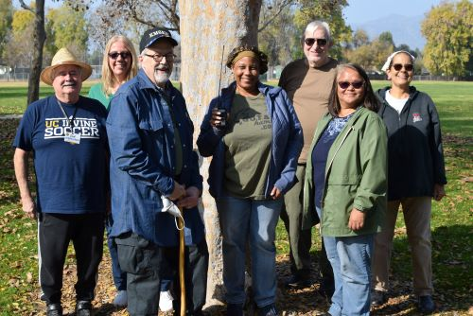
Gotahams get together for
Radio in the Park at Las Flores Park, La Verne
Pictured- l to r Jack, KM6UNQ; Susie, KM6YIF; Craig, KM6EIC; Sheila, KM6KNO; Ken, KC6WOK; Sonia, KN6CSX; Kathi, KD6CAF

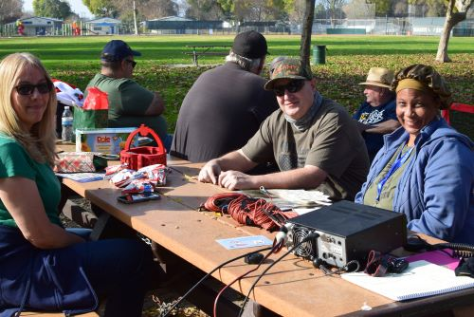
Using a IC7300 with a 31ft non-resonant vertical antenna with Icom AH4 remote tuner
Susie made a contact with N3BKV, David Ginsberg, Chino Hills, CA
Using 100W, Sheila contacted Joseph Allen, KJ7ZWJ, Spanaway, WA & Liz Morris, N6LY, Glen Ellen, CA
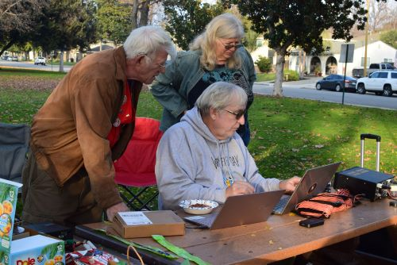
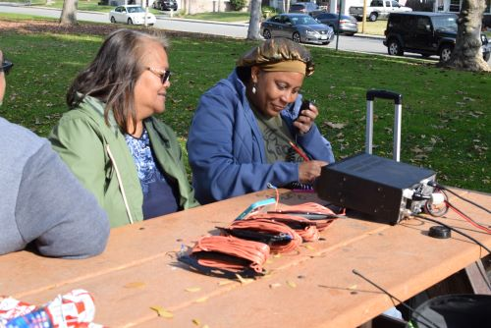
Art, W6TPG and Barbara, NP2MV watch Ken, KC6WOK use his computer to program a handheld radio.

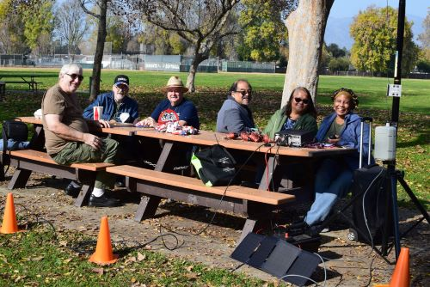

Radio in the Park group
l to r Ken, KC6WOK; Craig, KM6EIC; Jack, KM6UNQ; Dominic, KC6ZCR; Sonia, KN6CSX; Sheila, KM6KNO relaxing at the picnic table

Claremont Amateur Radio Society (C.A.R.S.) Swap Meet
Granite Creek Community Church
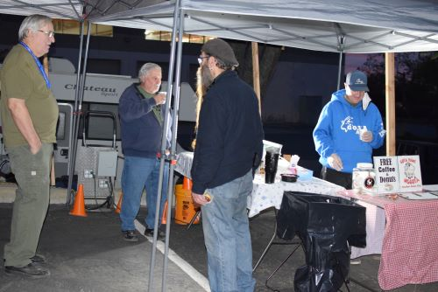
Set Up at 5:30am giving away free Coffee and Donuts to Swap Meet vendors and hams looking for radio treasures

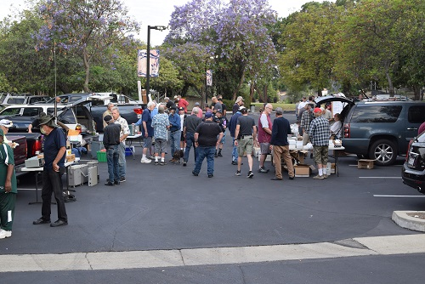

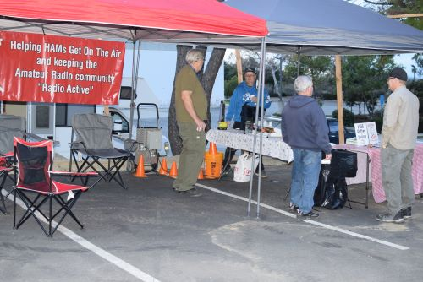

Ken, KC6WOK, tries out his drone during the Swap Meet
Mark, KM6AHY, checks out the drone flying over his coffee and donuts

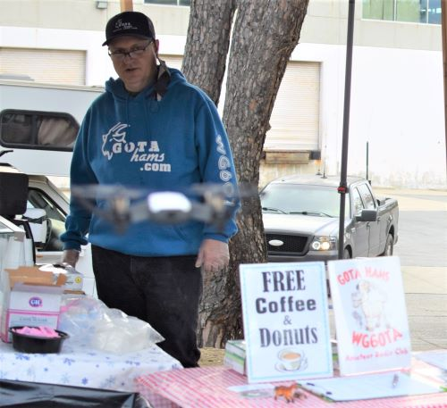
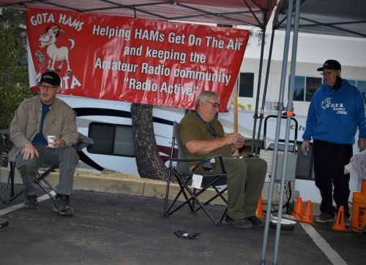

Lionel the Lizard by Kathi KD6CAF
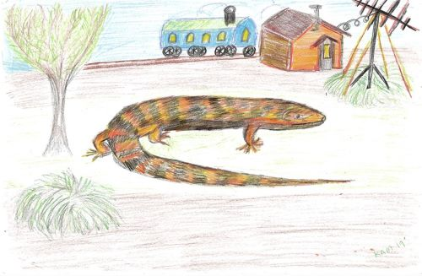

Lionel the Lizard lives among the evergreen trees and silver tasseled scrub bushes.
His home is an abandoned telegraph shack. On the wall is the Morse Code alphabet and an old, tattered drawing of Samuel Morse.
Outside the window sits an ornamental railroad car he uses to go on adventures with his friends.
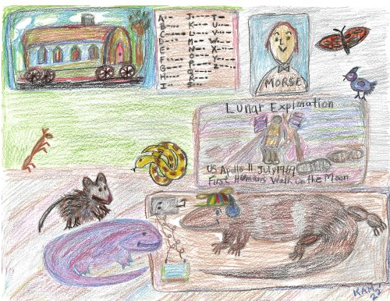
Using his long lizard snout, Lionel sits at his Morse Code key and taps out his message, CQ CQ CQ, This is L6ZRD, Lionel, QSL?

Suddenly he hears from his Gotaham friend, Dave, W6OOD who is contacting the International Space Station. The message says, the ISS is sending a sequence of images all week giving us more opportunities to get pictures from space.
Lionel thought it would be exciting to see if he could download an image from the ISS on his monitor in his ham shack. His friends gathered, and they waited. An image appeared on the monitor which read Lunar Exploration dated said July 20, 1969.

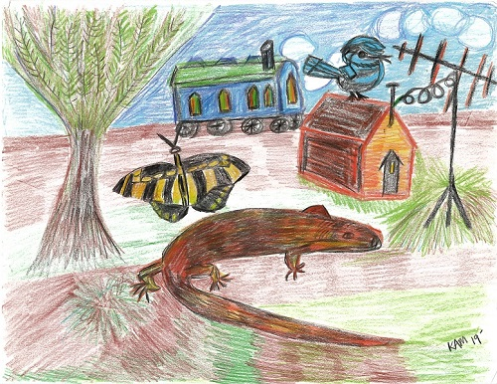

Lionel and his friends gathered outside his shack after they had seen the images transmitted from the International Space Station, ISS.
Using his Morse Code key, He sent out his message telling everyone to listen for the ISS traveling overhead and download images from space.
CQ, CQ, CQ, This is L6ZRD, Lionel, QSL?

