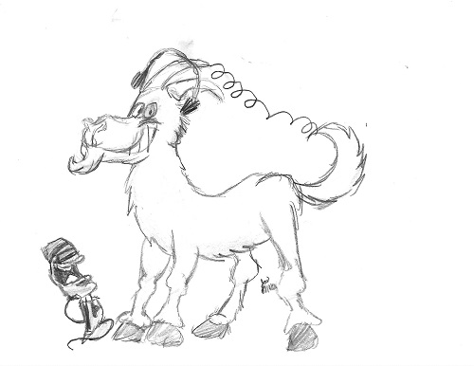
March/April 2022 Goat Notes

Image by James KN6IPL

Gotahams turns 3 years old
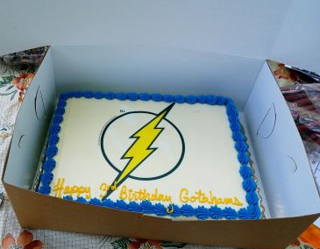
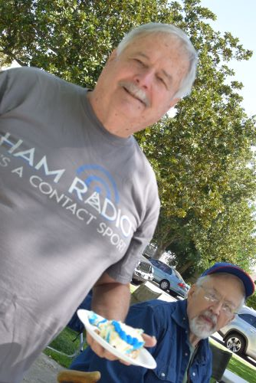

(l) Jack, KM6UNQ with (r) Craig, KM6EIC

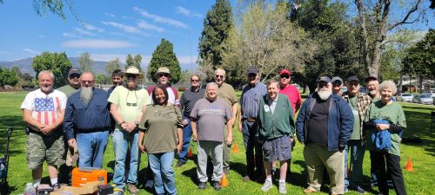
On Saturday, March 19 a group of Gotahams gathered at Las Flores Park in La Verne, CA
front row: l to r-Jere KN6PED; David KI6UXO; Bob KJ6VGX; Shelia KM6KNO; Jack KM6UNQ; Tim N6DLC; Dave K6EV; Grace K6FS-back row: l to r-Michael KN6HHW; Marco KN6SJQ; Jim KR6JK; Mark K6MBL; Ken KC6WOK; Mark KN6SBK; Keith KM6AVK; Chris N6CTA;
Bruce KM6WBI; Craig KM6EIC

Chris Anderson N6CTA (left) Savi W1SAV (right) discuss the cryptic t-shirt & learning CW.
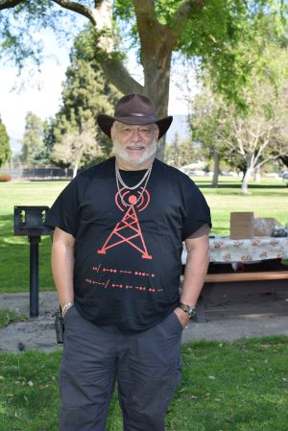
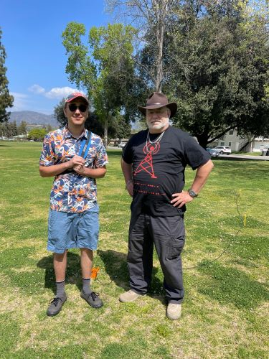
What does Savi’s
T-Shirt say?

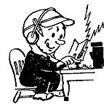
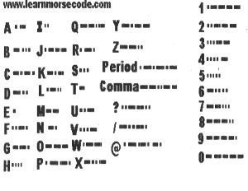

Elmers in the Park learn to use their Antenna Analyzers
0In addition to celebrating the Gotahams Third Birthday members and visitors become familiar with their antenna analyzers
Dave K6EV was one of many Elmers at the Park on Saturday, March 19
l to r: Lori, K6LRY; Dave, K6EV; Michael, KN6HHW; Maro, KN6SJQ; Mark, KN6SBK;
Sonia KN6CSX & Savi, W1SAV

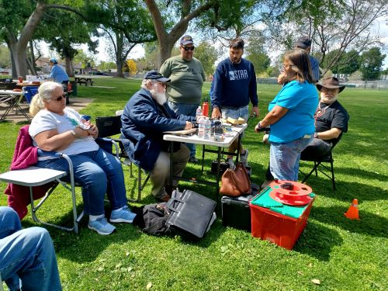

Dave K6EV writes: Many members brought antenna analyzers it was amazing. We had models from all over the spectrum and samples from Rigexpert, MFJ, Comet and a VNA for folks to compare. I am amazed at the number of analyzers the club members own.

The MFJ is very easy to use but doesn't graph or connect to a PC for data capture.
The Comet includes a small graphing display but no way to download it except take a snapshot.
The RigExperts do nice graphs and can be used either standalone or with a PC, saving the results for future reference. We focused on basic SWR measurements and members could see that all the different RigExpert models worked basically the same way. The most basic models cover all the HF bands, which is the most likely place for many hams to use them. Pricier models go up further in frequency. RigExpert is headquartered in Kyiv Ukraine, so here's hoping they are all safe and well.

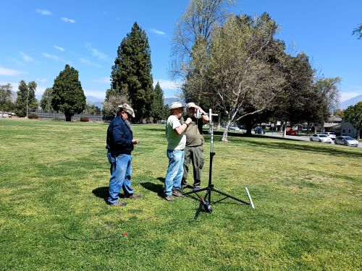
. Bob KJ6VGX, David KI6UXO and Ken KC6WOK look at a 2-meter Moxon Home Brew antenna

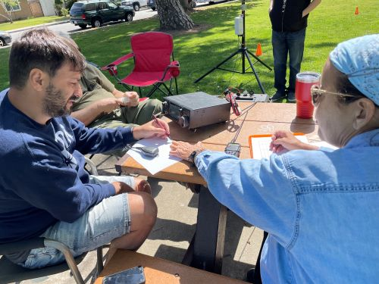

Kathi KD6CAF explains the radio log to new Gotaham Marco KN6SJQ

He made radio contacts and filled in his log sheet at Elmers in the Park- Great Job Marco
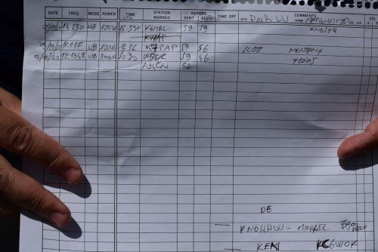

Gotahams admiring the
2M Moxon Home Brew antenna
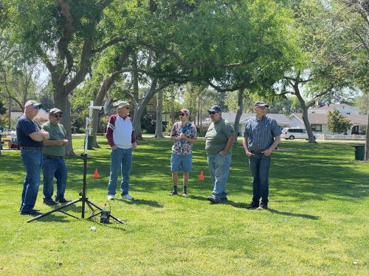

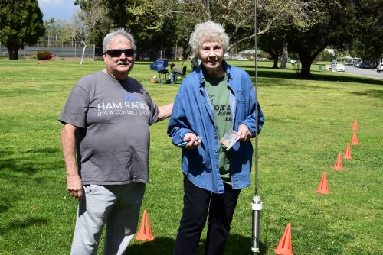

Grace, K6FS is with Jack, KM6UNQ discuss her new Wolf River Coil antenna.
She learned how to tune it up on all HF bands using her own antenna analyzer.

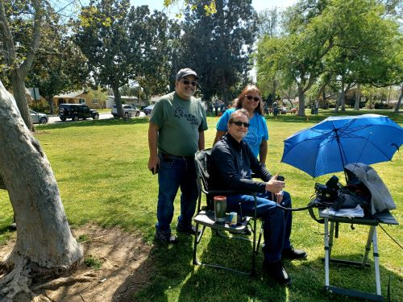

Sonia KN6CSX with husband Dominic KC6ZCR look at Mark’s, K6MBL,
radio set-up in a backpack perfect for
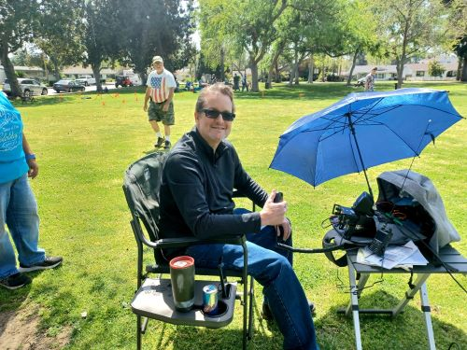
Parks On the Air (POTA) and Summits On The Air (SOTA) activation

We had a wonderful array of first-time visitors as well, several of which have decided to join the club including Savi - W1SAV, Marco - KN6SJQ, Chris N6CTA and Pier KN6OVN.
Bob -KJ6VGX and David - KI6UXO of Tri-City ACS became members too.
They each bring a range of experiences and we are happy to have them in the club.
Thanks to everyone. You made the day fun.
Members & visitors drove long distances to join us for the day; Ft. Mojave, Arizona; also from California, Alhambra, Brea, and Long Beach.

ELMERING IN THE PARK – SATURDAY, APRIL 16, CEDAR CREEK PARK, EASTVALE &
MAY 7, 10AM, LARKIN PARK, CLAREMONT

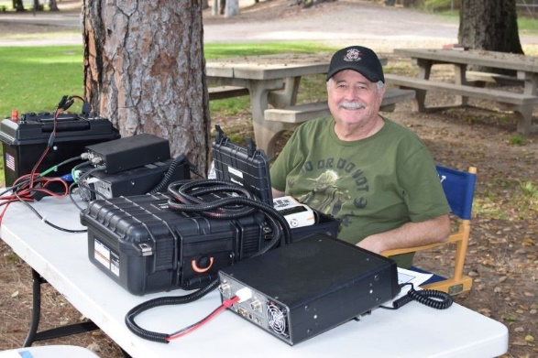

pictured Jack, KM6UNQ

Remember to bring a chair, a hat, sunscreen, and water, Radios & Antennas are always welcome.
We’ll offer a hands-on project that will include choosing and installing Power Pole terminals and connectors including the use of crimping tools. Assembled kits purchased by members will give us practice in soldering, connectors, and coax.

Also, wire stripping, wire splicing and soldering and application of heat shrink insulation tubing. You will use stripping, crimping, soldering and heat gun tools, assisted as needed. The completed project will be an intentionally short (less than 3 feet) DC power cable ideal for use at Radio-in-the-Park or similar portable operations to connect a portable battery to 100Watt HF rigs such as the IC-7300, FT991/A and many others. We will ensure your success and will test and inspect your cable.

INAUGURAL KIDCARE INTL. 5K RUN/WALK AT BONELLI REGIONAL PARK APRIL 23, 2022

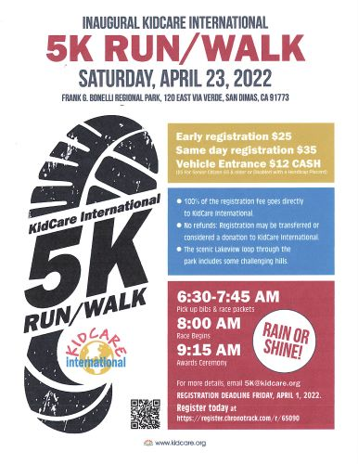

Originally planned for Spring of 2020 but delayed by the pandemic, the long-awaited inaugural run/walk event to benefit the programs of 501(c)3 organization KIDCARE INTERNATIONAL is scheduled for Saturday April 23.
Gotahams will provide Amateur Radio communications to address health/safety along the route.
We will gather at Bonelli Park, Via Verde Entrance at 5am Saturday morning to set-up, get our assignments and test our radios. Make sure your radio is fully charged and bring and extra battery. There is a $12 entrance fee after 5:30am
Volunteer positions for the KIDCARE walk/run MAY include:
1 to stay at event command post.
2 who can stand as course marshals at parking entrances/exits at the East Valley Picnic Area.
1 person who can stand at the front entrance to guide people to parking areas.
1 person who can accompany a county sheriff deputy.
1 person who can be stationed with the lifeguard.
1 athletic individual who can walk the course with the last participant (5 kilometers or somewhat over 3 miles.
Bring your chair and water. Frequencies will be discussed at a team ZOOM meeting to be announced and should be programmed and tested ahead of the event. Please bring your reflective vest or we will loan you one.

Contact Kathi Mixon kd6caf@gmail.com if you would like to participate or have questions

Spotlight on New Members

Gotahams pictured below are only a few of our new members.
If you would like to tell us about yourself, your hobbies or how you became interested in Amateur Radio please contact me at kd6caf@gmail.com
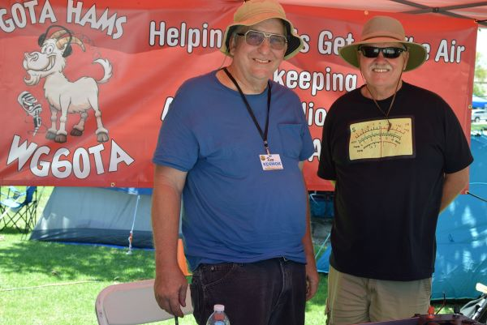
Keith Reeves, KM6AVK (right) with
Ken Mixon, KC6WOK (left)

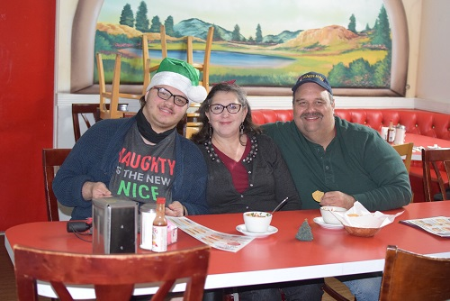
Michael Harwick KN6HHW
Michele Harwick KN6HHV
their son Mark Harwick KN6LYX

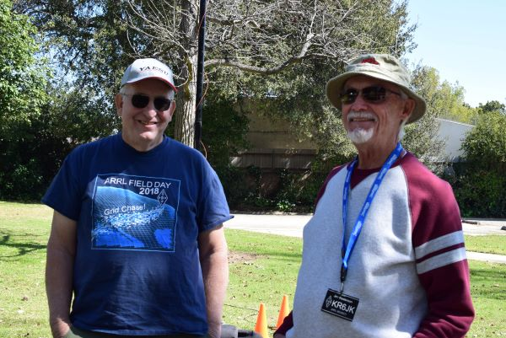
Jim Kesterson KR6JK (right)
Ken Mixon KC6WOK (left)
Jim is involved with La Verne CERT (Community Emergency Response Team) He is an instructor for Technician, General and Amateur Extra license classes

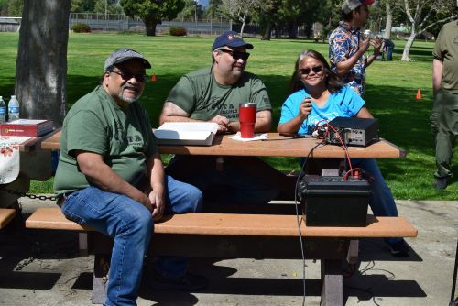
(left) Dominic Mercado KC6ZCR
(middle) Michael Harwick KN6HHW
(right) Sonia Silao KN6CSX at
Radio in the Park
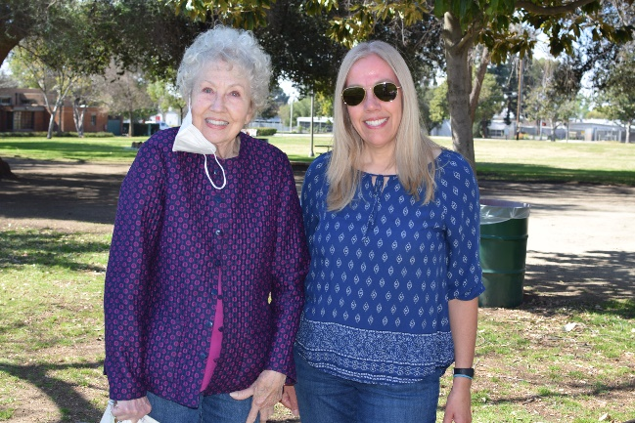

Grace, K6FS with
new member Susie KM6YIF

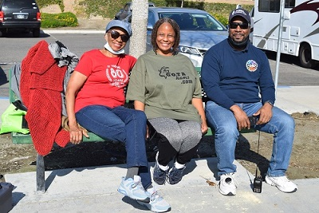
(middle) Sheila KM6KNO and
(right) Michael KJ6RIH Eure with mom (left) Sarah who is studying for her Technician license test

Field Day 2022
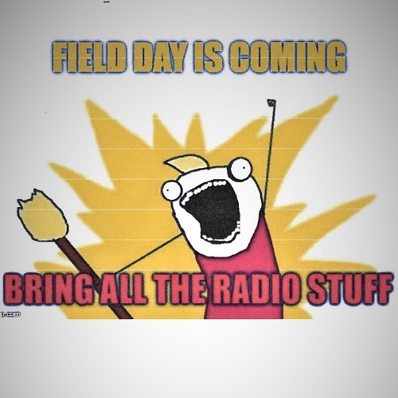

Jack, KM6UNQ, Field Day Coordinator
Location: Cedar Creek Park, Eastvale, California
If you would like to volunteer contact our coordinator Jack, km6unq@gmail.com
Friday: Set-up equipment for stations
Sunday: safely disassemble equipment
Sign-up to operate Amateur Radio Stations
Assist Craig, KM6EIC with Safety Monitor duties
Help young people learn about radio, electronics and morse code
Youth Station with Jose KK6JM & Emilia KJ6EMM
Next Field Day meeting on April 21st at 6pm

Repeater News
Since the road to the repeater was blocked by a landslide, we found another way to get to the top of the hill. It was purchased independently from Gotahams club funds but will use the club call sign WG6OTA. A new controller is ordered and plans for back-up power will be installed to keep the repeater On The Air.
Planned links include Echolink, All-Star and IRLP (Internet Radio Linking Project)
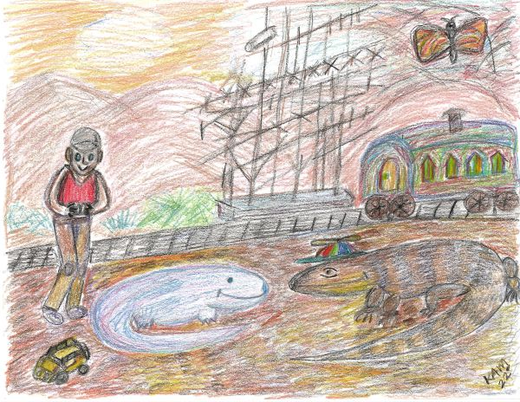
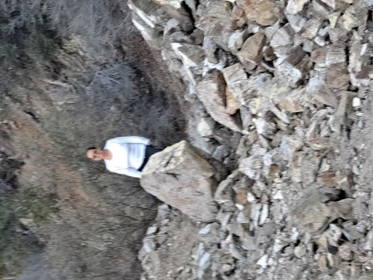

Rockslide on the Road Lionel & Sally visit the WG6OTA repeater
James KN6IPL drives his remote controlled jeep

Lionel Lizard L6ZRD by Kathi Mixon KD6CAF

Lionel Lizard lives in the mountain foothills among the evergreen trees and silver-tasseled scrub bushes. His home is in an abandoned telegraph shack.
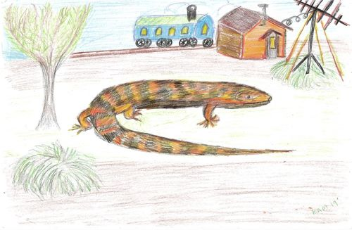

A picture of Samuel Morse hangs on the wall next to the Morse Code alphabet.
A colorful railcar sits outside the window.
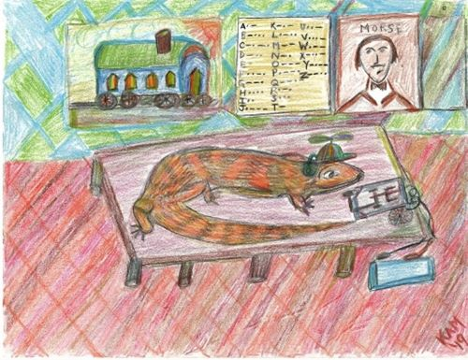

Lionel uses his long lizard snout to tap out his message in Morse Code to his friends CQ, CQ, CQ This is L6ZRD, Lionel, QSL?
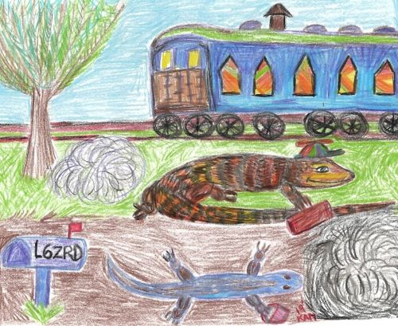
He receives a message from KR1SS, Kriss and Lyn K7DSE announcing Quartzfest in Arizona. Since Lionel and Sally enjoyed Quartzfest last year, they packed their bags and boarded the train for an Arizona adventure.

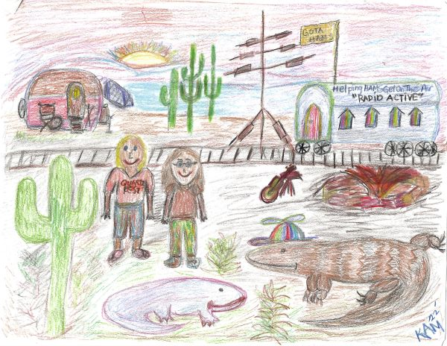
When the train stopped at Quartzfest Lionel and Sally saw Kris KR1SS and Lyn KJ7DSE at the welcome tent setting up tables, chairs and the information board showing activities for the week.

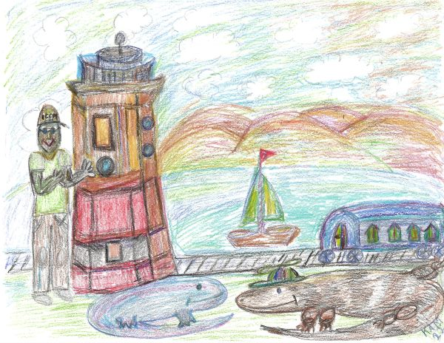

On the way home from Quartzfest the railcar moved through the beautiful state of Arizona. The two friends had fun looking out the window. When they passed through Lake Havasu, Arizona they saw colorful lighthouses around the lake.
They arrived home and shared stories of their Great Arizona Adventure.
CQ, CQ, CQ, This is L6ZRD Lionel, QSL?
The End

Upcoming Communication Events
Tour de Foothill Saturday, November 12, 2022
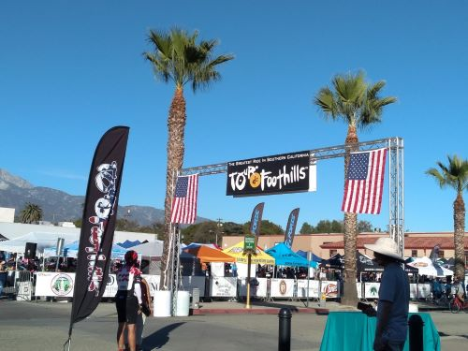
- Communication Volunteers
- Rest Stop Support
- SAG (Support and Gear) vehicle
SAG vehicles hold bike parts, pick up tired riders
- For more information contact: Kathi KD6CAF, kd6caf@gmail.com

Covina Christmas Parade, Saturday, December 3, 2022
- Logistics Meeting, Thursday, November 3, 2022
- For more information contact: Bruce Bolton, AG6YS, 1bcbolton@gmail.com

